Asilo, Rainier

Mariano, Jorjo

2 ECE – A

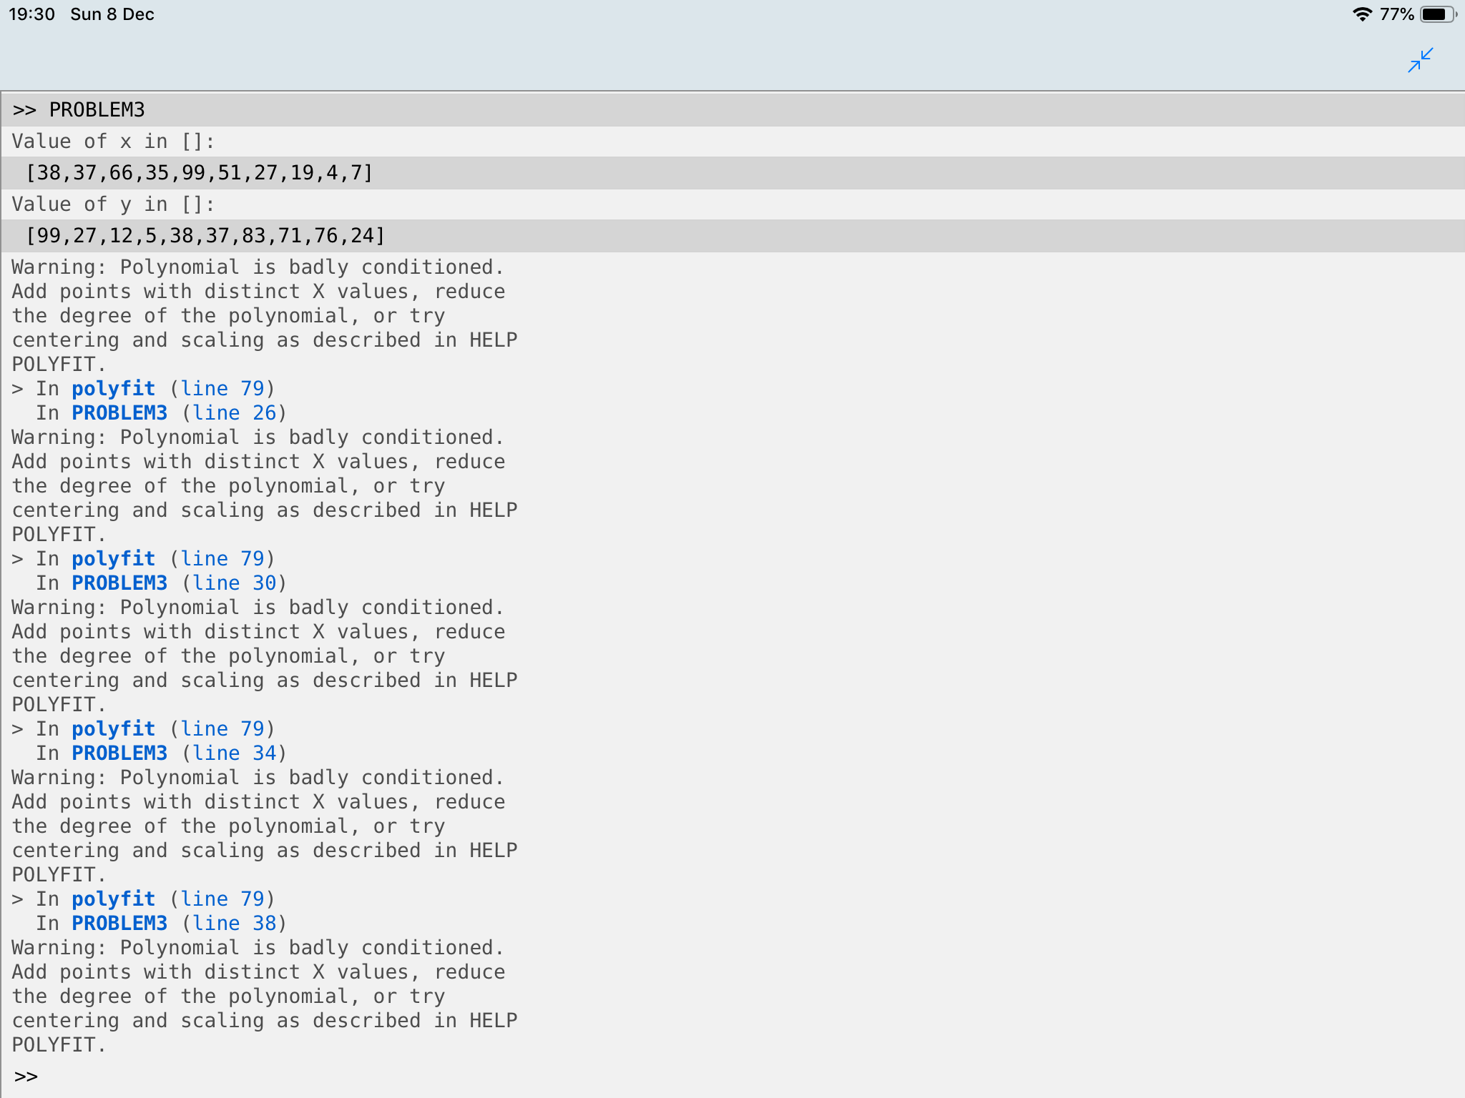**Machine Problem 3**

